**Assignment # 2**

**BSSE/BSCS – Fall 2015 (Enterprise Application Development)**

**Submission deadline:** Sunday (**25-March-2018 11:00 pm**)

**Total Marks:** 200

**Concepts Learning:**

**PHP, MySQL**

**Note:**

1- You need to create a **private** repository “**EAD_S18_A2_YourRollNumber**” on bitbucket

2- Provide access to “**bilal.shahzad@pucit.edu.pk**” and to your EAD TA bitbucket account.

3- Clone above repository in your **XAMPP** htdocs folder.

4- You should commit your changes regularly and push your commits often to server.

6- You need to update your repository link in following sheet against your roll number in **Assignment 2** column. Changes are being tracked there. Make sure your repository is **private**.

<https://docs.google.com/spreadsheets/d/1gN8m01-J2N_TBaY57tY6KzepdTQrmCHrMH3JjF23bj0/edit?usp=sharing>

CS TA: (IFTIKHAR LIAQUAT) [bsef14m034@pucit.edu.pk](mailto:bsef14m034@pucit.edu.pk) (Bitbucket ID: **bsef14m034**)

SE TA: SANA KANWAL [BCSF14M019@pucit.edu.pk](mailto:BCSF14M019@pucit.edu.pk) (Bitbucket ID:**BCSF14M019**)

Note: You need to fix your bitbucket issue. You may coordinate with me for those issues. Submission via any other medium will not be accepted.

**Late commits:**

Within 1 hour (after deadline): Deduction of 10% marks from obtained marks

Within 2 hours (after deadline): Deduction of 20% marks from obtained marks

Within 3 hours (after deadline): Deduction of 30% marks from obtained marks

Within 4 hours (after deadline): Deduction of 40% marks from obtained marks

Within 5 hours (after deadline): Deduction of 50% marks from obtained marks

After 5 hours of deadline: 0 Marks will be given in assignment.

1- You already have worked on Security Manager application in **Assignment 1**. You can use same HTML & basic client side validations from Assignment 1. But now you need to use PHP for Server Side validation + Database communication. Same validations should be applied here.

2- You should not use or refer SecurityManager.js in this assignment

3- Follow the **DB schema as it is** given at end of this document

4- If a user is not logged in, secure pages should not be accessible and user should be redirect to login screen.

5- Provide Logout option. This will logout user and will redirect him to login screen.

6- If user is logged in and tries to access a page (for which he is not authorized), redirect him to login screen.

7- Whenever a user will try to login, you need to add entry in table [**loginhistory**].

8- **Admin** user will have one more menu at top “Login History” which will show all login history in a grid (without any edit/view buttons)

9- Country table schema is added in schema section

**Check Assignment 1 for basic understanding of overall system.**

**Screens**

**Note:** For data management, there will be a separate screen to show data in grid and separate screen to save/update data. Once a record is added/updated successfully, redirect user to its relevant list page (e.g. UserList.php)

|  |  |
| --- | --- |
| **Login.php**. | There will be only one form for login. User will provide login & password. You will check data from [**users**] table. [**users**] table contain a field [**isadmin**]. Based on this field, you will decide whether a user is admin or not. What to do if user is admin OR what to do if user is not admin, this is already discussed in previous assignment. |
| **Home.php**: | This will be home screen (like previous assignment). Admin should see menus above and should have access on relevant pages. Non-Admin user should not have menus above and should not be able to access secure pages. Both should have logout button. Non-Admin home page should be like it was in Assignment 1. **Note:** There will not be two home pages. |
| **UserList.php:** | This will show data in grid (with delete/edit buttons) like last assignment. When user will click on Edit, user will be redirected to User.php. You may pass UserID in query string. When user will click on delete, you need to show confirm box and delete the record (just like last assignment) |
| **User.php:** | This will allow you to add or edit a user. If you get UserID from query string, it means open the form in edit mode (with data) otherwise open it in new mode. **You don’t need City drop down in this assignment. You need to add checkbox “Is Admin”.** |
| **RoleList.php**  **Role.php** |  |
| **PermissionList.php**  **Pemrission.php** |  |
| **RolePermList.php**  **RolePerm.php** |  |
| **UserRoleList.php**  **UserRole.php** |  |
| **LoginHistory.php** | It will show login history in a grid without any edit or delete buttons. Only Admin should be able to access this page. |

**Check following to understand Security System Assignment**

<https://drive.google.com/drive/folders/1wiKNhS6u5C4FKThry6HT7CsgfqseLjSa?usp=sharing>

**Introduction to bitbucket for Assignment**

<http://learninginurdu.pk/2018/03/08/git-part-17-how-to-use-bitbucket-with-tortoisegit/>

**Note:**

If you have understanding of Bootstrap and want to use it for UI perspective, you may use it. No restriction from my side.

**Database Schema to follow (will be updated here soon)**

* Store current date & time in [createdon] field when a new record is created
* Store logged in user user id in [createdby] field when a new record is created

**Users Table**

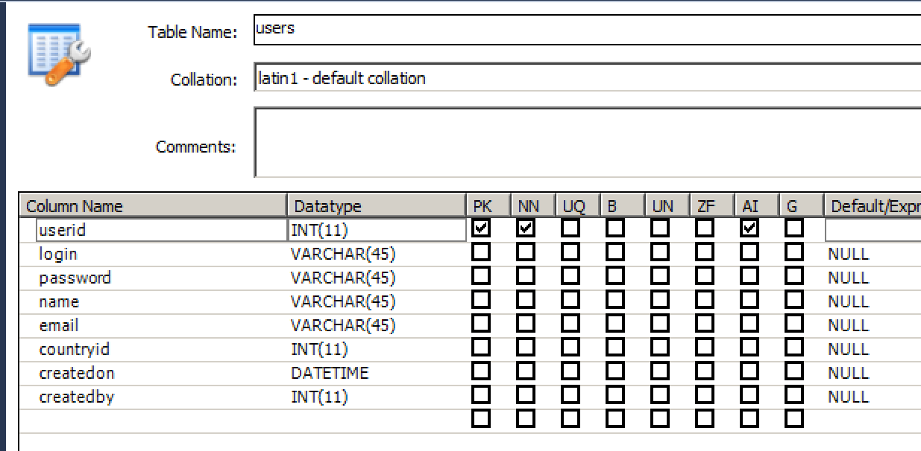

**Roles Table**

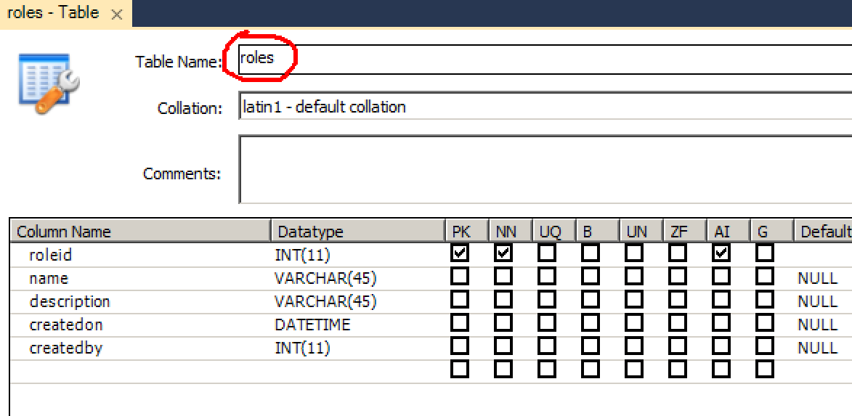

**Permissions Table**

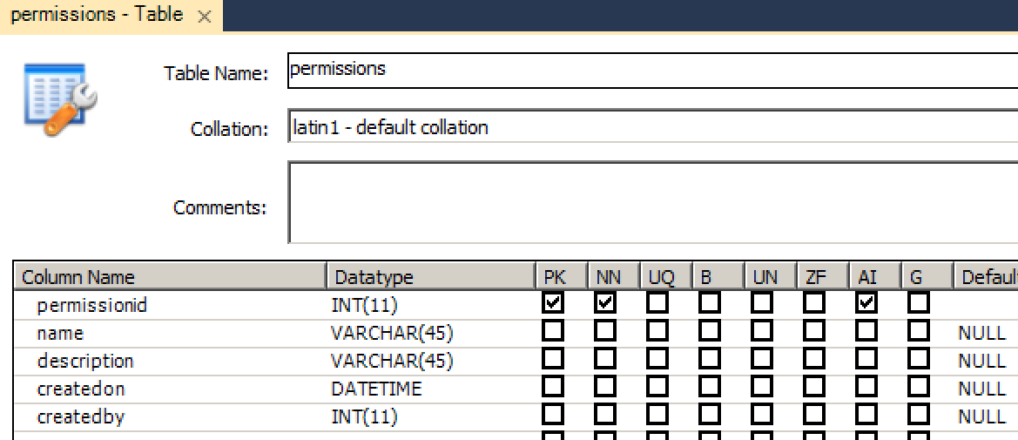

**Role Permission Table**

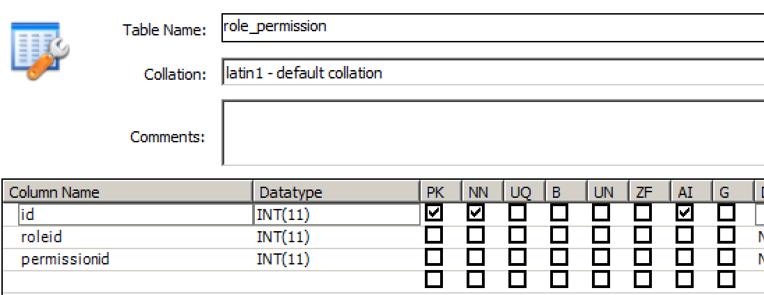

**User Role**

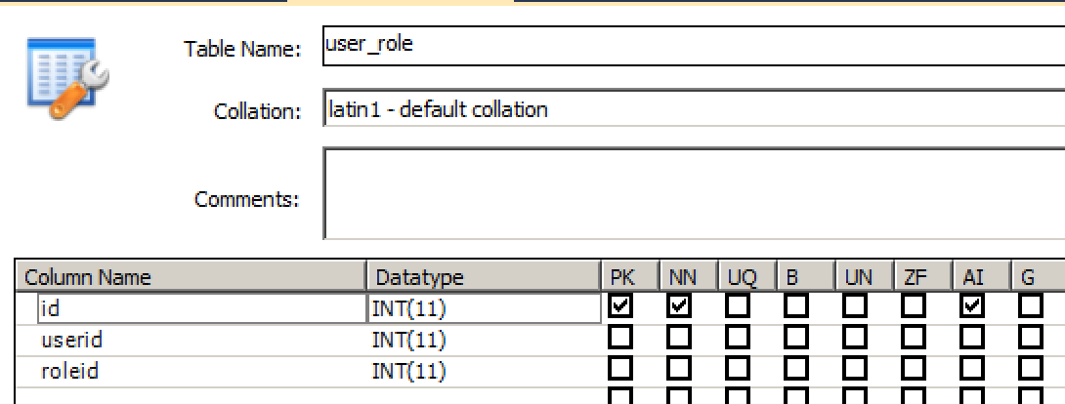

**Login History**

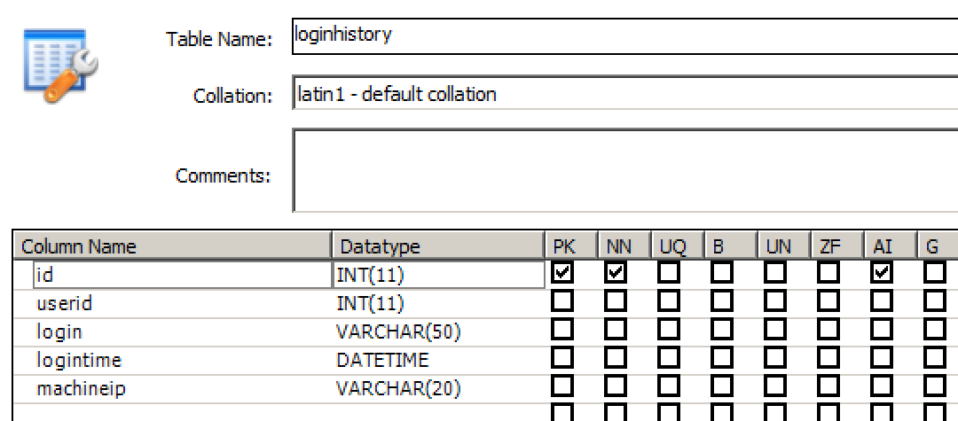

**Country (You may add some country directly in this table)**

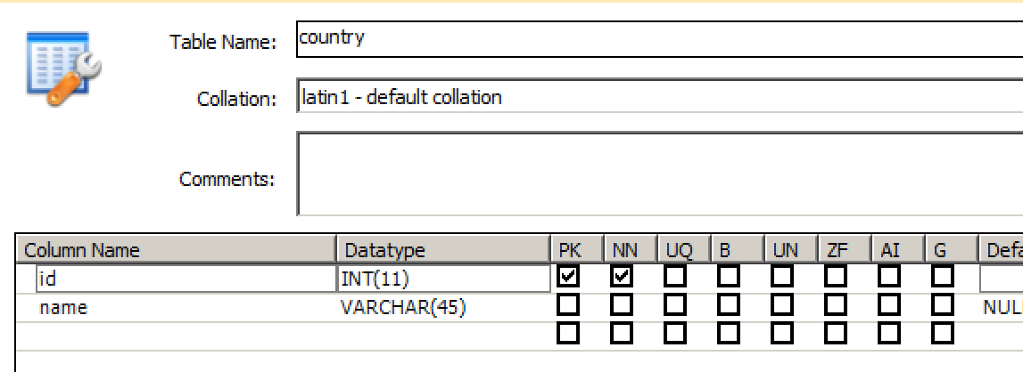

**FAQs from Assignment 2:**

**Q#1 can we use AJAX in the Assignment?**

**Answer:** No

**Q#2** Will admin also provide user id?

**Answer:** Every table has id column which is Auto generated (Auto increment)

**Q# 3** Do we have to assume that admin accounts can be more than one?

and non-admin user should only see his roles-permission like Assignment 1 and nothing else he can do?

**Answer:** You will have to add one user account in DB directly (with isadmin=1). There can be multiple admins. And yes non-admin user view will be same as it was in assignment 1.

**Q#4** what is the purpose of createdby column?

**Answer:** To track which user has created a record.

**Q#5** Can I write functions like getUserById, getAllUsers in one file i.e. functions.php and include this file in all other pages?

**Answer:** No restriction from my side regarding making such decisions.

**Q#6** Can we add link or button to give functionality to 'add user' in userList.php?

**Answer:** Yes. Or you may add a new menu at top to handle add/edit pages.